8/26/2025

Hp

[company name]

UI/UX FINAL PROJECT

AIMEN HASHMI

**UI/UX Design**

**Mobile Banking App**

* **Login:**

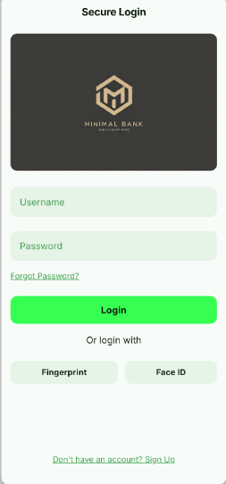

**Account Overview:**

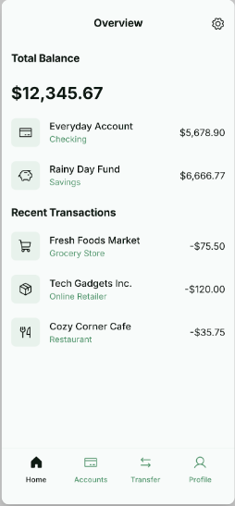

**Transaction History:**

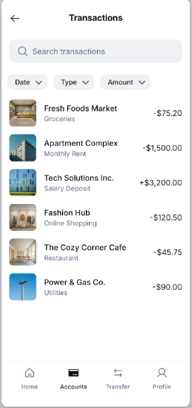

**Send/Receive Money:**

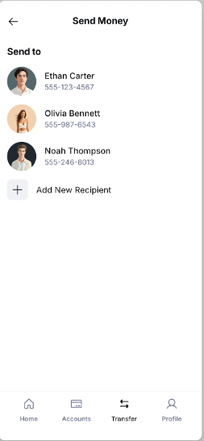

**Profile:**

